Single Phase – Three Phase

Single phase 230 VAC

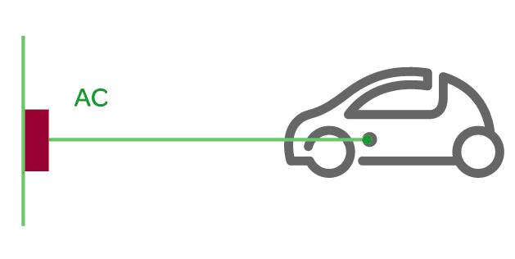Three Phase 400 VAC

Mode 1: standard socket-outlets present in residences.

* fire or electric injury risks if the electrical installation is obsolete or if certain protective devices are absent.

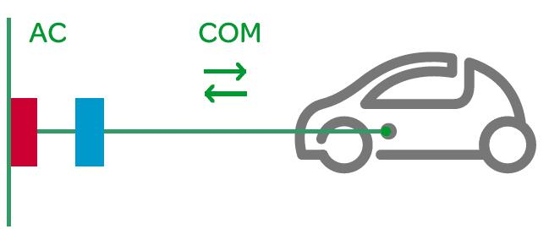

Mode 2: via household socket-outlets.

via a single-phase or three-phase network

more expensive than Mode 1 due to the specificity of the cable.

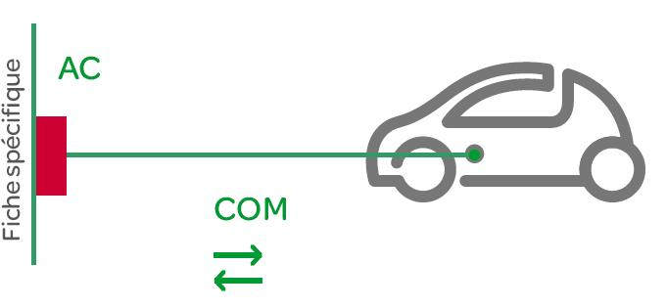Mode 3: onnected directly to the electrical network via specific socket.

This is the only charging mode that meets the applicable standards regulating electrical installations.

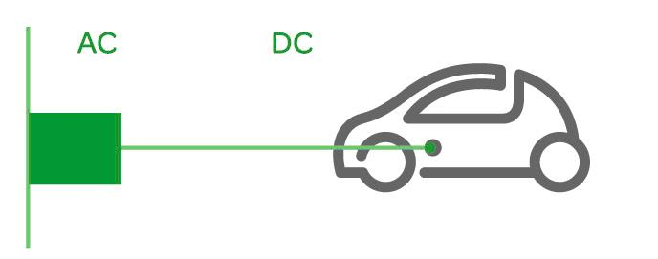

Mode 4: vehicle is connected to the main power grid through an external charger.

Plugs:

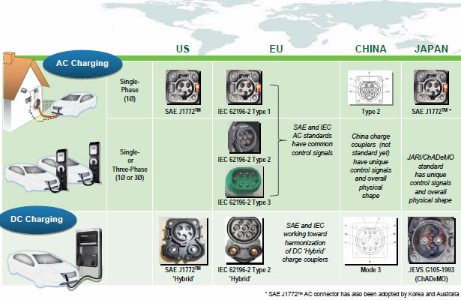

Battery Swapping

* Fast battery swapping under five minutes.

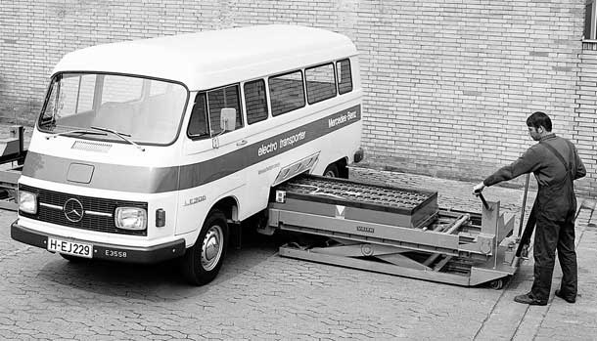

* Unlimited driving range where there are battery switch stations available.
* The driver does not have to get out of the car while the battery is swapped.
* The driver does not own the battery in the car, transferring costs over the battery, battery life, maintenance, capital cost, quality, technology, and warranty to the battery switch station company.
* Contract with battery switch company could subsidize the electric vehicle at a price lower than equivalent petrol cars.

The spare batteries at swap stations could participate in [vehicle to grid](http://en.wikipedia.org/wiki/Vehicle_to_grid) storage

**Smart grid communication**

Recharging a large battery pack presents a high load on the electrical grid, but this can be scheduled for periods of reduced load or reduced electricity costs. In order to schedule the recharging, either the charging station or the vehicle can communicate with the [smart grid](http://en.wikipedia.org/wiki/Smart_grid). Some plug-in vehicles allow the vehicle operator to control recharging through a web interface or smartphone app. Furthermore, in a [Vehicle-to-grid](http://en.wikipedia.org/wiki/Vehicle-to-grid) scenario the vehicle battery can supply energy to the grid at periods of peak demand.

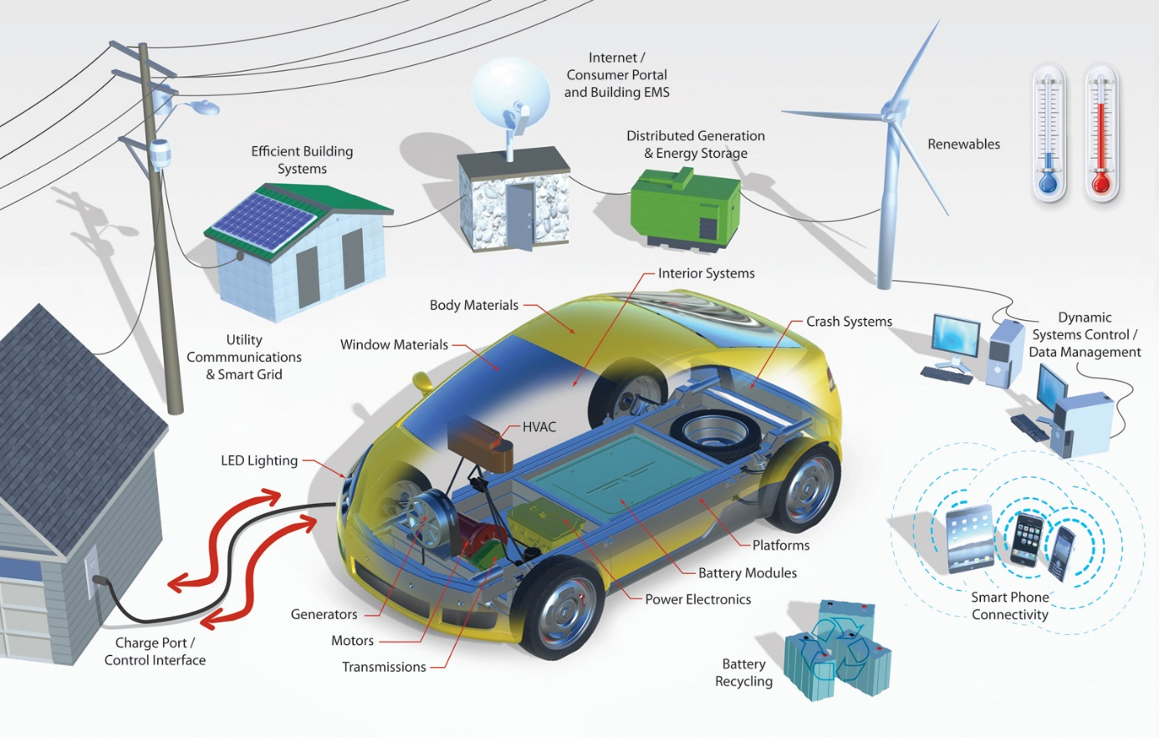

**Wifi Power Transfer**

